Git Project

Objective:
You will work on a project involving a simple website. You will learn and practice various Git concepts including branching, merging, handling merge conflicts, rebasing, pulling, versioning, and rolling back changes. This project is designed to be completed in 1 hour.

Project Setup (15 minutes)
- Install Git: Ensure Git is installed on your system. Verify with git –version.

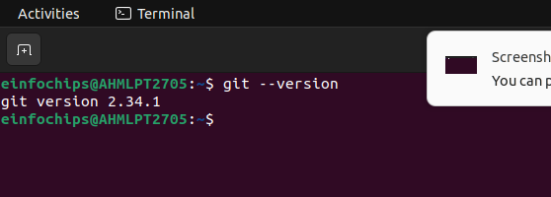
Set Up Git: Configure your Git username and email:
git config --global user.name "Your Name"
git config --global user.email "your.email@example.com"

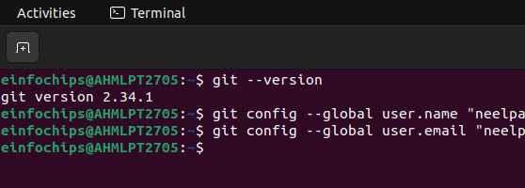
- Create a GitHub Repository:

- Initialize the Project:
git add .
git commit -m "Initial commit: Added project structure and index.html"
git push origin main
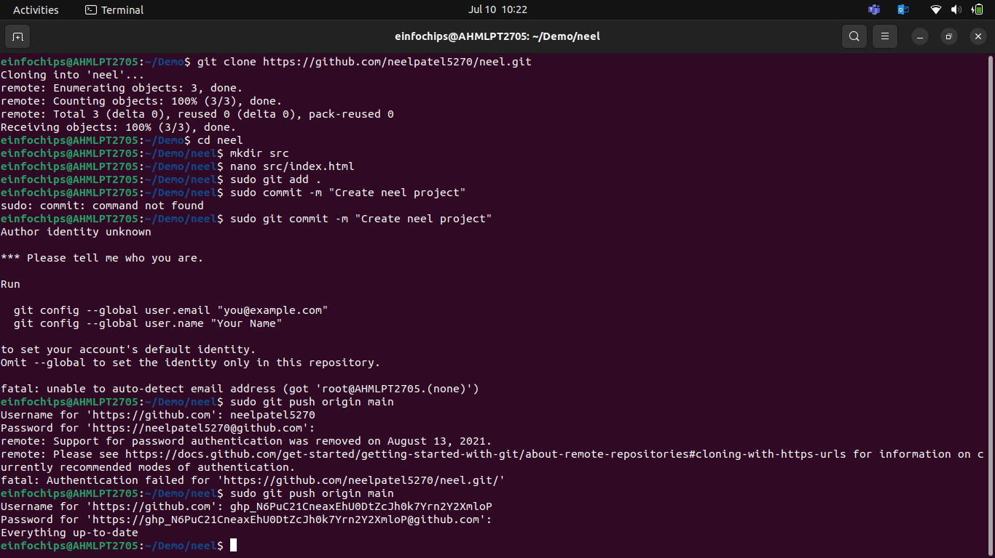

Exercise 1: Branching and Basic Operations
Create a New Branch:
git checkout -b feature/add-about-page

- Add a New Page:
Create about.html

Commit and push changes:
git add src/about.html
git commit -m "Added about page"
git push origin feature/add-about-page

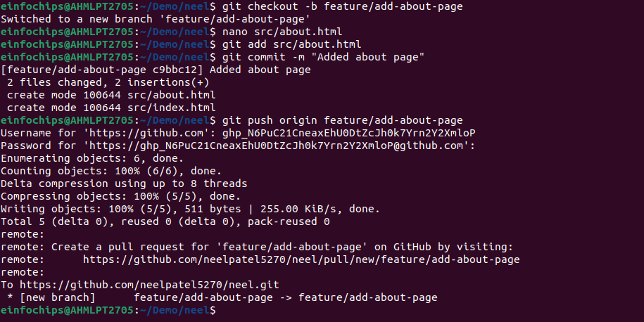

Exercise 2: Merging and Handling Merge Conflicts
Create Another Branch:
git checkout main
git checkout -b feature/update-homepage
- Update the Homepage:
Modify index.html:
Commit and push changes:
git add src/index.html
git commit -m "Updated homepage content"
git push origin feature/update-homepage
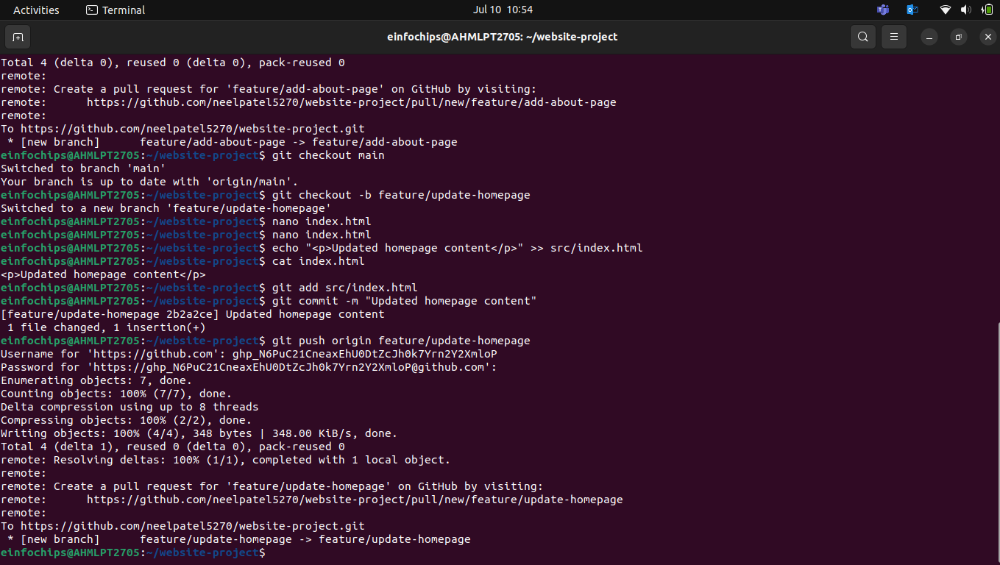
- Create a Merge Conflict:
Modify index.html on the feature/add-about-page branch:

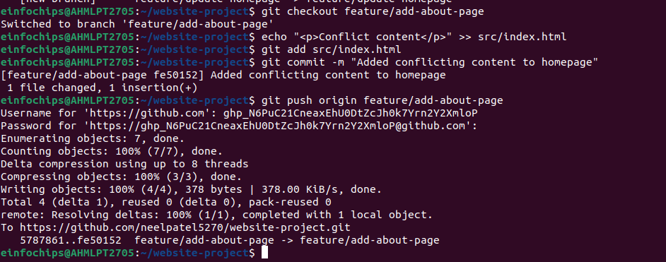

- Merge and Resolve Conflict:
Attempt to merge feature/add-about-page into main:
git checkout main
git merge feature/add-about-page

Resolve the conflict in src/index.html, then:
git add src/index.html
git commit -m "Resolved merge conflict in homepage"
git push origin main

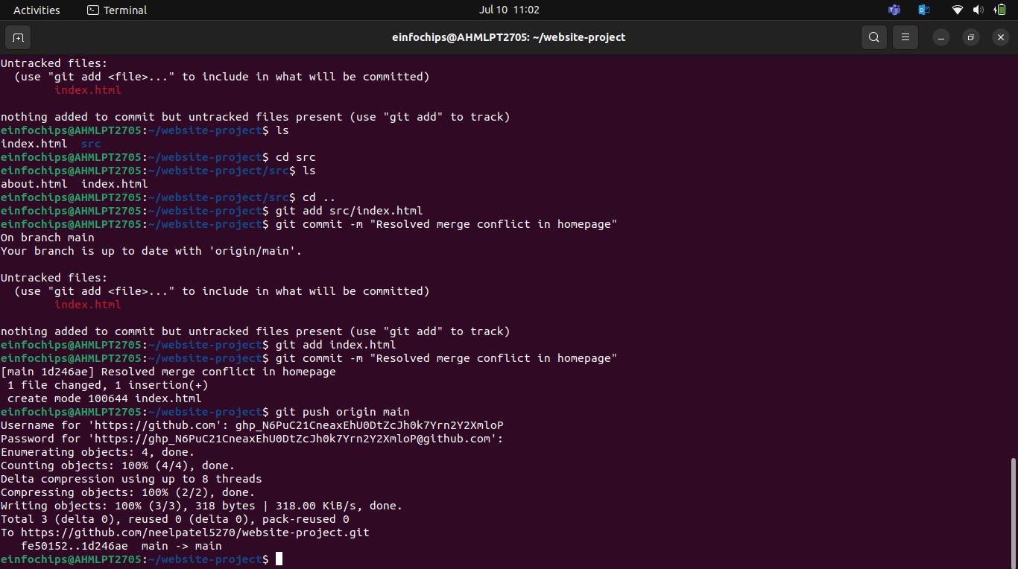

Exercise 3: Rebasing
- Rebase a Branch:
git checkout feature/update-homepage
git rebase main

Push the Rebased Branch:
git push -f origin feature/update-homepage
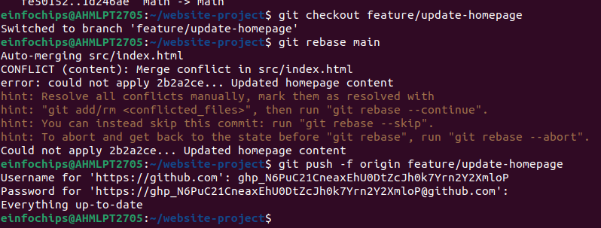

Exercise 4: Pulling and Collaboration
- Pull Changes from Remote:
- Simulate a Collaborator's Change:

- Pull Collaborator's Changes
Platform

Objective:
You will work on a project to collaboratively develop a simple blogging platform. You will practice various Git concepts including branching, merging, handling merge conflicts, rebasing, pulling, versioning, rolling back changes, stashing, and cherry-picking commits. The project is designed to be completed in 1.5 Hours

Exercise 1: Branching and Adding Features
Create a New Branch for Blog Post Feature:
git checkout -b feature/add-blog-post
- Add a Blog Post Page:

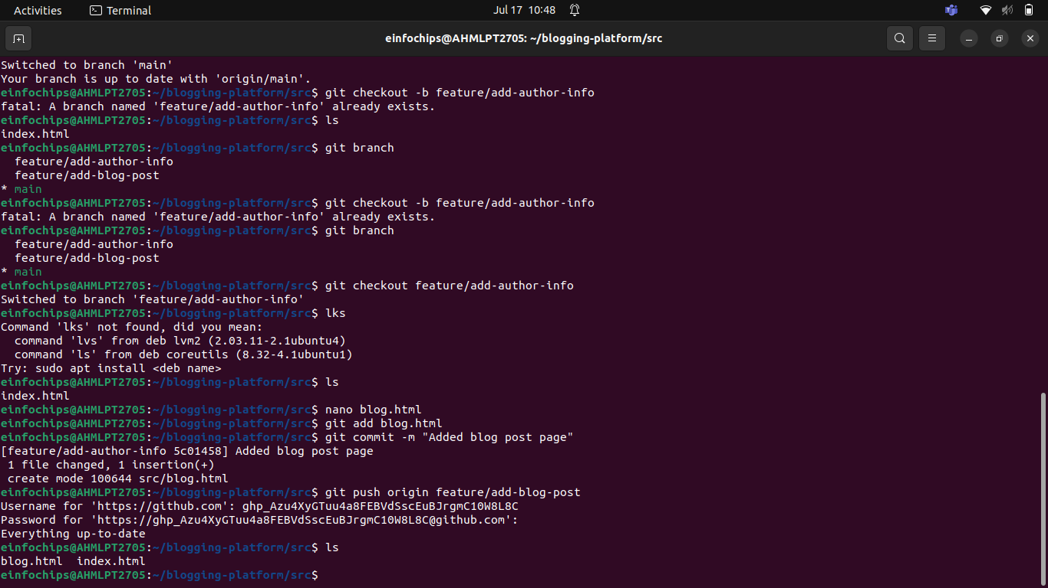

Exercise 2: Collaborating with Merging and Handling Merge Conflicts
Create Another Branch for Author Info:
git checkout main
git checkout -b feature/add-author-info

- Add Author Info to Blog Page:
Modify blog.html:
echo "<p>Author: John Doe</p>" >> src/blog.html

Commit and push changes:
git add src/blog.html
git commit -m "Added author info to blog post"
git push origin feature/add-author-info
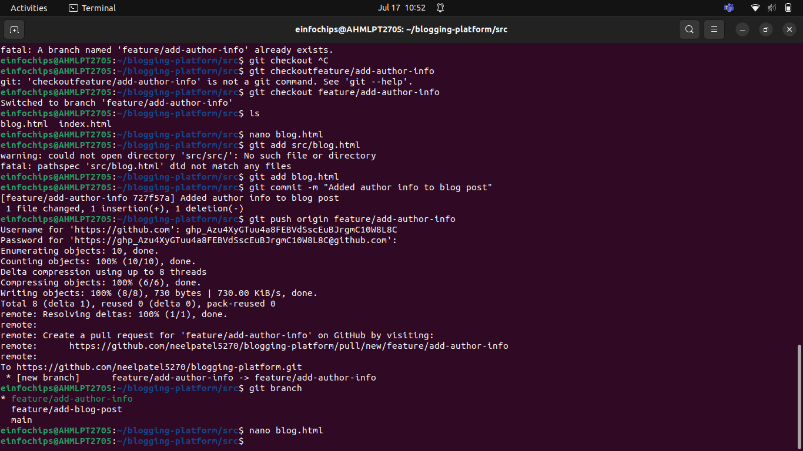
- Create a Merge Conflict:
Modify blog.html on the feature/add-blog-post branch:
git checkout feature/add-blog-post
git push origin feature/add-blog-post
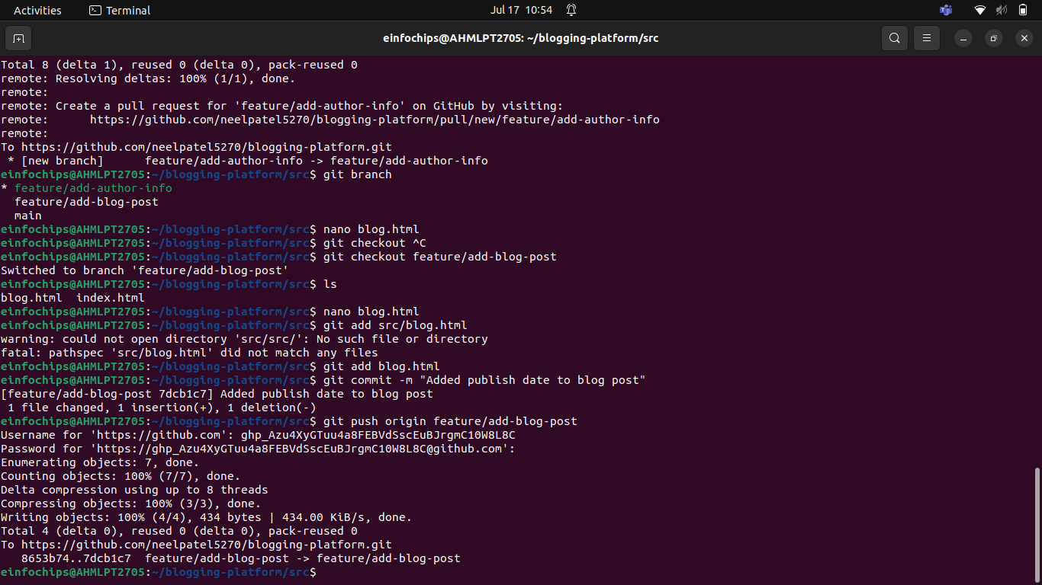
- Merge and Resolve Conflict:
Attempt to merge feature/add-blog-post into main:
git checkout main
git merge feature/add-blog-post

Resolve the conflict in src/blog.html, then:
git add src/blog.html
git commit -m "Resolved merge conflict in blog post"
git push origin main
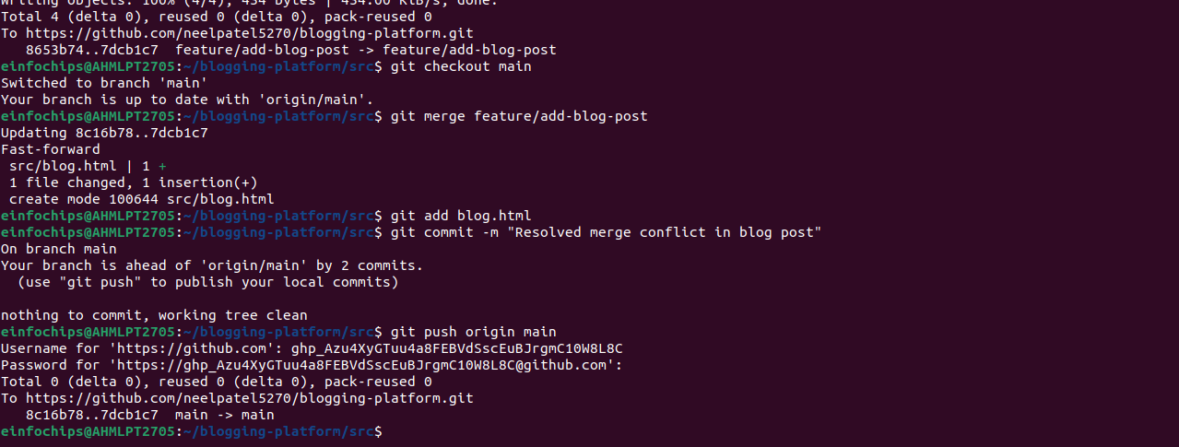

Exercise 3: Rebasing and Feature Enhancement (25 minutes)
- Rebase a Branch for Comment Feature:
Rebase feature/add-author-info onto main:
git checkout feature/add-author-info
git rebase main

- Add Comment Section:
Modify blog.html to add a comment section:
git add src/blog.html
git commit -m "Added comment section"
git push origin feature/add-author-info

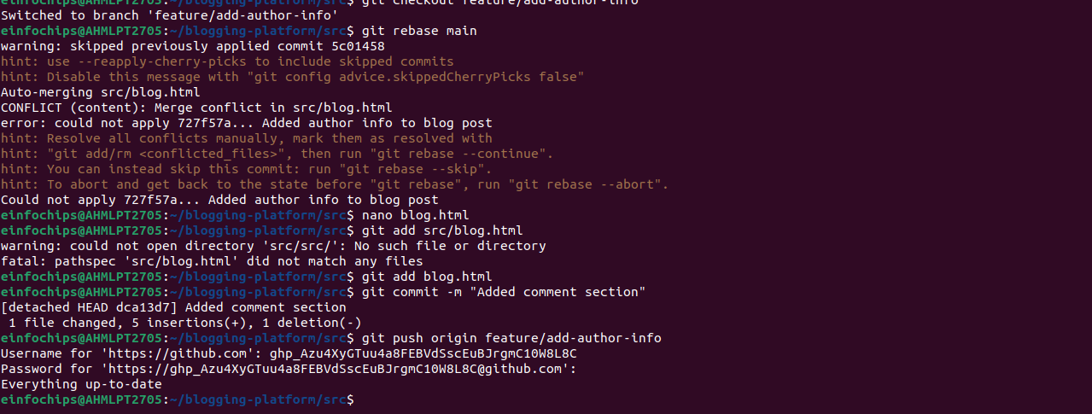

Exercise 4: Pulling and Simulating Collaboration
- Pull Changes from Remote:
Ensure the main branch is up-to-date:
git checkout main
git pull origin main

- Simulate a Collaborator's Change:
  - Make a change on GitHub directly (e.g., edit blog.html to add a new comment).
- Pull Collaborator's Changes:
Pull the changes made by the collaborator:
git pull origin main

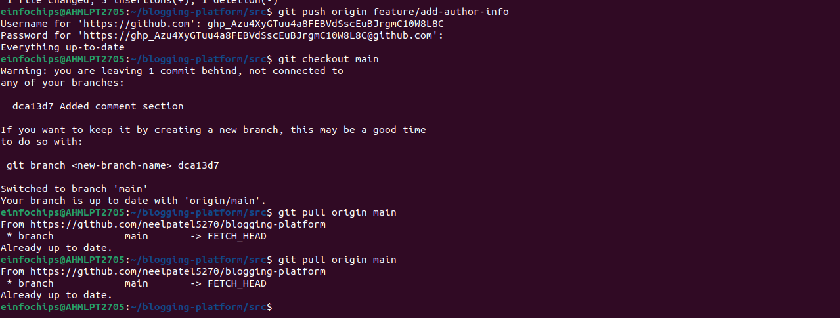

Exercise 5: Versioning and Rollback
- Tagging a Version:
git tag -a v1.0 -m "Version 1.0: Initial release"
git push origin v1.0
- Make a Change that Needs Reversion:
Modify blog.html:
git add src/blog.html
git commit -m "Incorrect comment update"
git push origin main
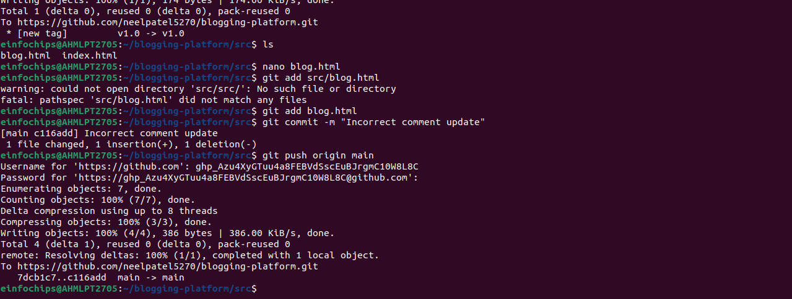
- Revert to a Previous Version:
